|  |
| --- |
| Crime Racer |
| Crime Racer FYP-I Report |
| Najam-us-Saqib (p10-6001) Shan Abutalib (p10-6022) Hassan Farooq (p11-6063) |

TABLE OF CONTETNTS

CHAPTER#1: INTRODUCTION 4

INTRODUCTION: 4

VISION OF PROJECT: 5

PRODUCT PERSPECTIVE: 5

PRODUCT FEATURES: 5

TECHNICAL ASPECTS: 5

REQUIREMENTS OF THE PROJET: 6

SOFTWARE REQUIREMENTS: 6

HARDWARE REQUIREMENTS: 6

CHAPTER#2: LITERATURE REVIEW 6

Different game engine and API in HTML5: 7

Impact.js: 7

Easel.js: 7

THREE.js: 7

Camera: 7

Orthographic Camera: 8

Perspective Camera: 8

Geometry: 8

Material: 8

Lights: 8

Ambient Light: 9

Directional Light: 9

Spot light: 9

Texture 9

Loaders: 9

OBJ Loader: 9

JSON Loader: 9

Collada Loader: 9

Binary Loader: 10

Texture Loader: 10

Image Loader: 10

Renderers: 10

Canvas Renderer: 10

WebGL Renderer: 10

CHAPTER#3: Software Requirement Specification 10

Purpose 10

Intended Audience and Reading Suggestions 10

Product Scope 11

References 11

Overall Description 11

Product Perspective 11

Product Functions 12

User Classes and Characteristics 12

Operating Environment 12

Design and Implementation Constraints 12

User Documentation 12

Assumptions and Dependencies 12

External Interface Requirements 12

User Interfaces 12

Hardware Interfaces 12

Software Interfaces 12

Communications Interfaces 13

System Features 13

Use case Diagram 1 13

Use case Diagram 2 15

Use case 1 16

Use case 2 16

Use case 3 17

Use case 4 17

Use case 5 18

Use case 6 18

Use case 7 19

Use case 8 20

Use case 9 20

Use case 10 21

Use case 11 21

Use case 12 21

Use case 13 22

Other Nonfunctional Requirements 22

Performance Requirements 22

Software Quality Attributes 22

CHAPTER#4: SOFTWARE DESIGN DESCRIPTION 24

PURPOSE: 24

SCOPE: 24

OVERVIEW: 24

SEQUENCE DIAGRAM: 25

Tree Position: 25

Wall Position: 26

Car Movement: 27

Player Car Position 28

CHAPTER#5: IMPLEMENTATION 28

Introduction: 28

THREE.js API Download: 29

Building the Game: 31

Plane making: 31

Car making: 32

Car Movement Controls: 33

Walls and Trees making: 33

Setting up the Lights: 33

Collision Detection: 35

Discrete Collision: 35

Continues Collision: 35

Ways to detect the collision: 35

Bounding Box: 35

Ray Casting: 36

Calculate the distance: 37

Bullet Creation: 37

Fake tracer: 38

Ray casting: 38

Enemies Creation: 40

# 

# 

# CHAPTER#1: INTRODUCTION

## INTRODUCTION:

The goal of this project is to develop a 3d car racing game in which player needs to stand at first position in race and the player has to destroy other cars using weapons attached to the car to limit the window of opponents and also save own car from the firing of other cars.

## VISION OF PROJECT:

With the increased demand in the gaming field people needs more and more entertainment in games. Day by day new technologies are emerging to enhance the real effects of games to make them more realistic therefore our emphasis is to develop the game full of entertainment and develop it as much realistic as we can.

## PRODUCT PERSPECTIVE:

As increasing of interest of people on gaming side so this product is aimed to entertain the people, who has interest in e gaming. This product is self-contained product. This product will be user friendly and will provide a mean of entertainment to people.

## PRODUCT FEATURES:

The project will have the following features

* Different graphical effects
* Animation
* Sound effects
* Artificial intelligence (AI)
* Lighting effects
* Destructible environment
* Allow users to play the game via keyboard.

## TECHNICAL ASPECTS:

The technologies we are going to use in the project “Crime Racer” are as follow:

* HTML5
* Adobe Photoshop
* Adobe After Effects
* 3D MAX Model maker
* Microsoft Office Visio
* Astah
* Notepad++
* THREE.JS API’s
* Aptana

## REQUIREMENTS OF THE PROJET:

### SOFTWARE REQUIREMENTS:

Software that we will use to develop this project includes:

* Operating system (Microsoft XP, Microsoft Vista, Microsoft windows7)
* Adobe Photoshop
* 3D MAX
* Adobe After Effects
* Microsoft Office Visio
* Astah
* Notepad++
* Adobe Illustrator
* THREE.JS API’s
* Aptana

### HARDWARE REQUIREMENTS:

* Processor (core i3 2.55 GHZ)
* RAM (4 GB)
* At Least HDD(40 GB)
* GPU (1 GB)

# CHAPTER#2: LITERATURE REVIEW

As we are developing a game so there are lots of tools and language that are used to build the game. The tools that are in the market a game engine that are used in developing games like Unity3D, UDK, Cry engine etc and almost every language supports game development. We are making a game resembling the RC Mini Racer that is made in Unity3D and we chose HTML5 for this purpose. The main reason for this is that if we see Unity3D it’s a game engine so there is less learning with programming point of view. Secondly it’s a software while HTML5 is Language for the World Wide Web so there is no need of installing this and every browser support this except Microsoft internet Explorer, but Microsoft gives support of this language in IE9. In Unity3D we also face the License issues as in the free version of Unity3D we don’t have all the features. Thirdly the main programming language of both Unity3D and HTML5 is JavaScript so we need to lean this language first in both cases and as unity3D is a game engine so it support or help the programmer in most of the cases like it has its own physics so there is no programming learning in this case while in HTML5 we have to do all the stuff by ourselves.

WebGL is also available in HTML5 for making 3D web based games and it is JavaScript API for rendering the 3D and 2D graphics with any compatible browser without the use of any Plug-ins. WebGL is based on the OpenGL ES 2.0 and is accessed using Document Object Model Interfaces.

General game techniques that are collision, physics and Artificial Intelligence all are handled in HTML5 Canvas TAG. Gravity, acceleration, speed and weight distribution can handle in HTML5 Canvas TAG.

HTML5 not only support games but also supports web applications. There are lots of tutorials for making games in HTML5 available on internet.

## Different game engine and API in HTML5:

As we are developing the game in HTML5, there are dozens of game engine and JavaScript APIs in HTML5 that are used for making the games. The most popular APIs and gaming Engine are following

* Impact.js
* Easel.js
* THREE.js

### Impact.js:

This is a gaming engine and as well as editor for programming the game and a very popular engine in HTML5 gaming but the problem with this engine is that it is commercialize and is not freely available, so we go for the next option that is Easel.js.

### Easel.js:

Unlike the impact.js it is a JavaScript API for the game programming and developed under the umbrella of **creative.js.** This API has many other APIs for a good support in the audio and animation named **sound.js** and **tween.js** respectively, we work a little bit on it but it seems hard to use this library as it has complex syntax and semantics. This is an open source API, freely available, but due to its hard and complex we go for the third one that is THREE.js.

### THREE.js:

The more powerful and stable API among impact.js and Easel.js. It’s is an open source, freely available API. It’s have lots of features and tools that help the programmer to build a good and interactive web based games. This API has simple and easy syntax that makes this API more interactive form the programming point of view. Features that are supported in THREE.js are as follows.

## Camera:

This feature helps the user to see the things that are in the scene and there are two types of the cameras

* Orthographic camera
* Perspectivecamera

### Orthographic Camera:

It’s a nature thing that we see the distant object small and near object large, but this camera does not fulfill this condition. It shows each and every object according to its size whether they are far way or near the camera.

### Perspective Camera:

It’s a nature thing that we see the distant object small and near object large, this camera fulfill this condition as it shows object small in size that are far away and shows object larger in size that are near.

## Geometry:

This feature helps us to make different things like cylinder, plane, cube etc. there are many geometries which are supported in THREE.js

* Plane Geometry
* Cube Geometry
* Sphere Geometry
* Cylinder Geometry

Names of the geometries tell that which geometry is use for what purpose.

## Material:

There are some materials that are used for the Mesh to give it a nice look.

* Mesh Basic Material
* Mesh Lambert Material
* Mesh Face Material

Basic difference between these and **Mesh Basic Material** is that the above two have effects of light on them but **Mesh Basic Material** does not have any effect of light on it that’s why we did not use any of the light in the given example.

## Lights:

This component used to light up the scene and there are many different types of the lights in this API some are given below

* Ambient light
* Directional light
* Spot light

### Ambient Light:

It’s the light that has effect on all the objects equally from all sides.

### Directional Light:

In this light we have the light coming from one specific direction and in THREE.js we use this light for casting the shadows.

### Spot light:

In this light we have light coming from a spot and this type is also used for the shadow casting in THREE.js.

Texture**:**

This feature is used to map an image texture on the material so that it can feel like the texture image for example if we create an wall material and map a wall texture on it than it gives a look like the wall.

## Loaders:

There are many built-in loaders for loading and importing the different types of objects in to the game.

* OBJ Loader
* JSON Loader
* Collada Loader
* Image Loader
* Texture Loader
* Binary Loader

### OBJ Loader:

This loader is used to load the object with the extension of **.obj**.

### JSON Loader:

JSON stands for JavaScript Object Notation. This loader is used to load the object with the extension of **.js**. THREE.js API provides the additional editor to convert the .obj/.dae/.bin files to convert them in **.js** file. There is built-in support for this loader in THREE.js API as this is the primary loader of this API and we don’t need to include any header file for this loader.

### Collada Loader:

This loader is used to load the objects with the **.dae** extension. Collada files are XML files with a .dae extension which stands for "**Digital Asset Exchange**." Collada is typically the file format used to transfer data between digital content creation (DCC) tools such as Maya, 3ds Max, and Rhino. THREE.js uses the Document Object Model (DOM) parser to parse the xml files and to retrieve the data from it.

### Binary Loader:

This loader is used to load the binary files with .bin extension.

### Texture Loader:

Use to load the texture from an image and to give a look to the objects that are loaded by OBJ Loader or Collada Loader.

### Image Loader:

This loader works with the texture loader, basically use to load the image for the texture.

## Renderers:

There are two main renderers that are supported in THREE.js.

* Canvas Renderer
* WebGL Renderer

### Canvas Renderer:

The Canvas renderer displays your beautifully crafted.

### WebGL Renderer:

The WebGL renderer displays your beautifully crafted scenes using WebGL, if your device supports it.

This renderer has way better performance than Canvas Renderer.

# 

# CHAPTER#3: Software Requirement Specification

## Purpose

The purpose of this Software Requirements Specification (SRS) is to provide a design as well as technical functionality and logic for a **Car Racing Game in 3D environment**. This document will provide the client and the user with a basic understanding about the Game’s performances and its goals. It describes how we built the game, what challenges we will face and how we will overcome those issues to meet our goal. In short this document will describe the functional specification for the game CRIME RACER.

## Intended Audience and Reading Suggestions

This document is for the developers and the intended users that are relate to the game CRIME Racer.

## Product Scope

The target of this project is to build a **3D Car Racing Game**. This will be a level based game. Its sole purpose is to provide an entertainment to its users. The main benefit of our software is that it is free as well as its online on internet along with the facility that there is no need to install it.

## References

Scirra “Scirra Arcade”

URL: <http://www.scirra.com/arcade/example/13/html5-physics-example>

“The Game Programming Wiki”

URL: <http://forum.gpwiki.org/viewtopic.php?f=30&t=10782>

Unity Technology “Unity3D”

URL: [http://unity3d.com](http://unity3d.com/)

Mrdoob “Three.js”

URL:<https://github.com/mrdoob/three.js>

Jerome Etienne “3D Physics”

URL: <http://learningthreejs.com/blog/2012/06/05/3d-physics-with-three-js-and-physijs/>

Chris Strom “Collision and Detection”

URL:<http://japhr.blogspot.com/2012/07/collision-detection-in-threejs.html>

Francik “Collision and Detection”

URL: <http://francik.name/html5/three.js/examples/webgl_collisions_trigger.html>

## Overall Description

### Product Perspective

Interest of people on gaming side is increasing so this product is aimed to entertain the people, who has interest in e gaming. This product is self-contained product. This product will be user friendly and will provide a means of entertainment to people.

### Product Functions

The product will facilitate the user to play car racing game online without installing it. It gives all effects that a modern car racing gives. It allows the user to destroy other cars by using the missiles and mines to win the race.

### User Classes and Characteristics

* User should be able to use a browser, mouse and keyboard.

### Operating Environment

We will build the game in HTML5 using THREE.js API for this game that runs on every operating system and every modern browser like Firefox, chrome etc. There should be good graphic card to run the game.

### Design and Implementation Constraints

As we are building this game in HTML5 so we have issues regarding the browser compatibility as we have to deal with different browser at a time. As this game is 3D so our graphic card should enough to render the scenes so that it gives the realistic effect in the game and the language we are dealing with is JavaScript that is not an object oriented language.

### User Documentation

There will be complete online help for the user to play the game.

### Assumptions and Dependencies

Assumptions that we have made are as follows

* There should be modern browser like Firefox, chrome, IE9 and etc.
* There should be good graphic card to run the game.

Dependencies that we have are as follows

* We should have to manage the game in low graphic so that it covers all the range of the graphic card.

## External Interface Requirements

### User Interfaces

The main software user interface will be simple having basic options at the starting of the game like.

* Play game
* Mute Volume

There will be Head-up Display (HUD) on the side of the screen while you playing game that shows

* Time
* Health of the player

### Hardware Interfaces

* Mouse
* Keyboard
* Screen

### Software Interfaces

This game is using THREE.js API for the development of the 3D modeling.

### Communications Interfaces

As this game is a browser based game this game use the HTTP communication standard. This game will be available as a site so that it can be played online.

## System Features

There are some features of the game that will be explained in this section via use cases and by plain English text to illustrate how the game will work, what the user can do and he/she can’t do and who are the enemies and what the enemies can do and they can’t do.

### Use case Diagram 1

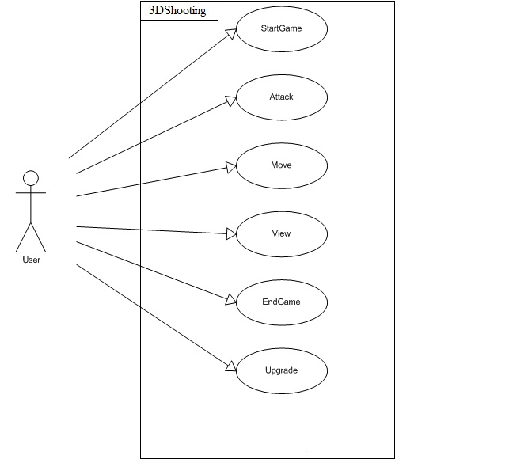

### Use case Diagram 2

## 

## Untitled1

### Use case 1

|  |  |
| --- | --- |
| **Use Case Number** | 1 |
| **Name** | Initialize |
| **Rationale** | User wants to play game |
| **Summary** | User starts the game |
| **Pre-Condition** | User has successfully opened browser |
| **Player** | User |
| **Description** | User initializes the game and the menu appears that have “Start” ,“option” and “difficult level” |
| **Alternative Path** | None |
| **Post-Condition** | Start game option will come on the screen |

### Use case 2

|  |  |
| --- | --- |
| **Use Case Number** | 2 |
| **Name** | Start Game |
| **Summary** | User start to play the game |
| **Rationale** | User want to play game |
| **Pre-Condition** | User has started the game successfully |
| **Post-condition** | Game will start and now user is in the playing mode |
| **Player** | User |
| **Description** | User starts the game and now the user is in the game with some enemy |
| **Alternative Path** | None |

### Use case 3

|  |  |
| --- | --- |
| **Use Case Number** | 3 |
| **Name** | Exit Game |
| **Summary** | User exit the game after playing |
| **Rationale** | User wants to quit the game after playing it |
| **Pre-condition** | Game should be in playing mode or user life ends |
| **Post-condition** | Game will close after this event |
| **Player** | User |
| **Description** | In this event user exit the game as his/her health gets zero or he/she wants to close the game after playing it |
| **Alternative path** | None |

### Use case 4

|  |  |
| --- | --- |
| **Use Case Number** | 4 |
| **Name** | Restart game |
| **Summary** | User restart the game |
| **Rationale** | User has to start the game again |
| **Pre-condition** | Game should be in playing mode |
| **Post-condition** | Game will restart from the same level |
| **Player** | User |
| **Description** | In this event user is prompted to play the game again as his/her life line ends or he/she wants to play the game from the same level again. |
| **Alternative path** | None |

### Use case 5

|  |  |
| --- | --- |
| **Use Case Number** | 5 |
| **Name** | Fire Bullet |
| **Summary** | User fire the bullet on the enemy |
| **Rationale** | User has to fire the bullet to kill the enemy to win the race and to breaks the box to get bounty |
| **Pre-conditions** | User must have the bullets to fire |
| **Post-condition** | Bullet will fire and hit the target or can miss the target. |
| **Player** | User |
| **Description** | In this event user fire the bullets on his/her enemies so that he/she can eliminate the enemy and user can fire the bullet on the boxes too to get the bounty like health. |
| **Alternative path** | None |

### Use case 6

|  |  |
| --- | --- |
| **Use Case Number** | 6 |
| **Name** | Movement |
| **Summary** | Movement of car with keys and firing with mouse |
| **Rationale** | Interaction of player with the game via keyboard and mouse |
| **Pre-condition** | Game should be in the active play state game |
| **Post-condition** | User moves the car or fires the bullet, missile or places the mines. |
| **Player** | User |
| **Description** | User can use the keyboard for the movement of the car and user can use the mouse to fire the bullet/ missile/ mines.  Keyboard keys:  W: For forward movement  S: For backward movement  D: For right turn  A: For left turn  Z: Missile firing  X:Mines  Space: Bullet Firing  Mouse click  Left Click: For bullets  Right Click: For missiles |
| **Alternative path** | None |

### Use case 7

|  |  |
| --- | --- |
| **Use Case Number** | 7 |
| **Name** | Resume |
| **Summary** | User Resume the game |
| **Rationale** | User has to resume the game |
| **Player** | User |
| **Pre-condition** | Game should in pause mode |
| **Post-condition** | Game will resume from where user pause the game |
| **Description** | In this event user can resume the game where user pause the game |
| **Alternative path** | None |

### Use case 8

|  |  |
| --- | --- |
| **Use Case Number** | 8 |
| **Name** | Pause |
| **Summary** | User pause the game |
| **Rationale** | User has to pause the game |
| **Pre-condition** | Game should in playing mode |
| **Post-condition** | Game will pause on the current location |
| **Description** | In this event user can pause the game during the playing mode |
| **Alternative path** | None |

### Use case 9

|  |  |
| --- | --- |
| **Use Case Number** | 9 |
| **Name** | Next Level |
| **Summary** | User go to the next level |
| **Rationale** | User can go to the next level |
| **Pre-condition** | User must clear the current level by eliminating the enemies |
| **Post-condition** | User will go to the next level |
| **Description** | If user eliminate the all the enemies and complete all the targets than he will be prompted to enter in to the next level |
| **Alternative path** | None |

### Use case 10

|  |  |
| --- | --- |
| **Use Case Number** | 10 |
| **Name** | Weapon change |
| **Summary** | User change the weapon |
| **Rationale** | User can be change the weapon |
| **Pre-condition** | Game should in playing mode and user must have other weapons to change them |
| **Post-condition** | User will have the changed weapon |
| **Description** | In this event user can change the weapon(missile, bullets) game during the playing mode |
| **Alternative path** | None |

### Use case 11

|  |  |
| --- | --- |
| **Use Case Number** | 11 |
| **Name** | View |
| **Summary** | User can change the camera position |
| **Rationale** | User can change camera position during the playing mode |
| **Pre-condition** | Game should in playing mode |
| **Post-condition** | Game camera position change. |
| **Description** | In this event user can change the camera position according to its need. |
| **Alternative path** | None |

### Use case 12

|  |  |
| --- | --- |
| **Use Case Number** | 12 |
| **Name** | Pick up mine |
| **Summary** | User can pick up mine. |
| **Rationale** | User can pick up mine during the playing mode. |
| **Pre-condition** | Game should in playing mode and user have the deficiency of the mines |
| **Post-condition** | User get the mine |
| **Description** | In this event user can pick the mine during the playing according to its need. |
| **Alternative path** | None |

### Use case 13

|  |  |
| --- | --- |
| **Use Case Number** | 13 |
| **Name** | Pick up missile |
| **Summary** | User can pick up missile |
| **Rationale** | User can pick up missile during the playing mode |
| **Pre-condition** | Game should in playing mode |
| **Post-condition** | User get the missile |
| **Description** | In this event user can pick the missile during the playing according to its need. |
| **Alternative path** | None |

## Other Nonfunctional Requirements

### Performance Requirements

As this is an online game so there is need to have a good internet connection and good graphics card on your computer so that the game loads in a better way and all the component of the game can load without any interruption.

### Software Quality Attributes

There are some software quality attributes that we are concern with

Maintainability- there will be proper documentation of the code so that the code can be modified and update in the future easily.

Robustness- the game will durable for the longer period of the time.

Usability- game should be built in such a way that it can address the wide range of the users and keyboard shortcuts should be modifiable.

Availability- there will be a good server on which the game will upload so that the game should available 24/7 for the user.

# CHAPTER#4: SOFTWARE DESIGN DESCRIPTION

## PURPOSE:

This Software Design Document (SDD) establishes the software design for our project, in which we have provided some basic UML diagram like Activity diagram, Domain model, and sequence diagram. The audiences of this document are our project supervisor, project coordinator and students.

## SCOPE:

The objective of the SDD is to define the architecture and design of our project. This document outlines the high-level architecture, interface architecture, and interface design.

## OVERVIEW:

The remaining document contains the architectural design of our project, this architectural design can be made with the help of UML diagrams i.e. sequence diagram, activity diagram etc

## SEQUENCE DIAGRAM:

### Tree Position:



### Wall Position:



### Car Movement:



### Player Car Position



# 

# CHAPTER#5: IMPLEMENTATION

## Introduction:

In this chapter we will describe that how we develop our game from the very basic. This is an important portion of this report as it focuses on the techniques that we used to develop this game. This section is also important for those who want to make games in HTML5 as this report will provide a good foundation to build the game. We will try our best to explain the key concepts of the game development.

We chose HTML5 platform for making the game as this is very hot field in computer science now-a-days. We are making game using THREE.js API that is a JavaScript API for making 3D games using WebGL. So first, we will like to explain how to download the THREE.js API.

## THREE.js API Download:

This is a 3D JavaScript light weight library to build the 3D game. This library can be downloading from the following address: <http://mrdoob.github.com/three.js/>. This API provides a strong base for the development of the games into HTML5. Now take a look on a brief code to get started with the THREE.js. After downloading the API just include it into the html project by this command

<script src="build/three.min.js"></script>

After this just declares some of the variables that we will use in the code before start just note that this code will make a box made up of wire type structure.

***var*** camera**,** scene**,** renderer**;**

***var*** geometry**,** material**,** mesh**;**

As this is the part of the JavaScript so put whole of the code in between **<script></script>.**  Now actual code started.

***function*** init**()** **{**

camera **=** ***new*** THREE.PerspectiveCamera**(** 75**,** window.innerWidth **/** window.innerHeight**,** 1**,** 10000 **);**

camera.position.z **=** 1000**;**

scene **=** ***new*** THREE.Scene**();**

geometry **=** ***new*** THREE.CubeGeometry**(** 200**,** 200**,** 200 **);**

material **=** ***new*** THREE.MeshBasicMaterial**(** **{** color**:** 0xff0000**,** wireframe**:** ***true*** **}** **);**

mesh **=** ***new*** THREE.Mesh**(** geometry**,** material **);**

scene.add**(** mesh **);**

renderer **=** ***new*** THREE.CanvasRenderer**();**

renderer.setSize**(** window.innerWidth**,** window.innerHeight **);**

document.body.appendChild**(** renderer.domElement **);**

**}**

In this following **init()** function we have made a camera of perspective type and set its position of

Z-coordinate but remember that we can set the position of X- coordinate and Y- coordinate from the same command by replacing the z with x or y. In the code we have CubeGeometry(x, y, z) function, its mean that we can set the height, length and width of the cube by giving them values if we left the parameters field empty the **default** **parameter** values will set to **zero**. In the next we setup the scene and then made a box named **mesh** of cube geometry and with the basic material on it and include this in the scene by the **scene.add(mesh)** command. Note that there are many other **geometries** and **materials** in THREE.js that we will explain later on. In the next line we start the canvas renderer and setup the screen width and the height and keep in mind that there are some other renderers too that are mentioned in the documentation of THREE.js but we will also explain them in the coming game code.

***function*** animate**()** **{**

// note: three.js includes requestAnimationFrame shim

requestAnimationFrame**(** animate **);**

mesh.rotation.x **+=** 0.01**;**

mesh.rotation.y **+=** 0.02**;**

renderer.render**(** scene**,** camera **);**

**}**

In this we animate the whole scene by rendering the scene.

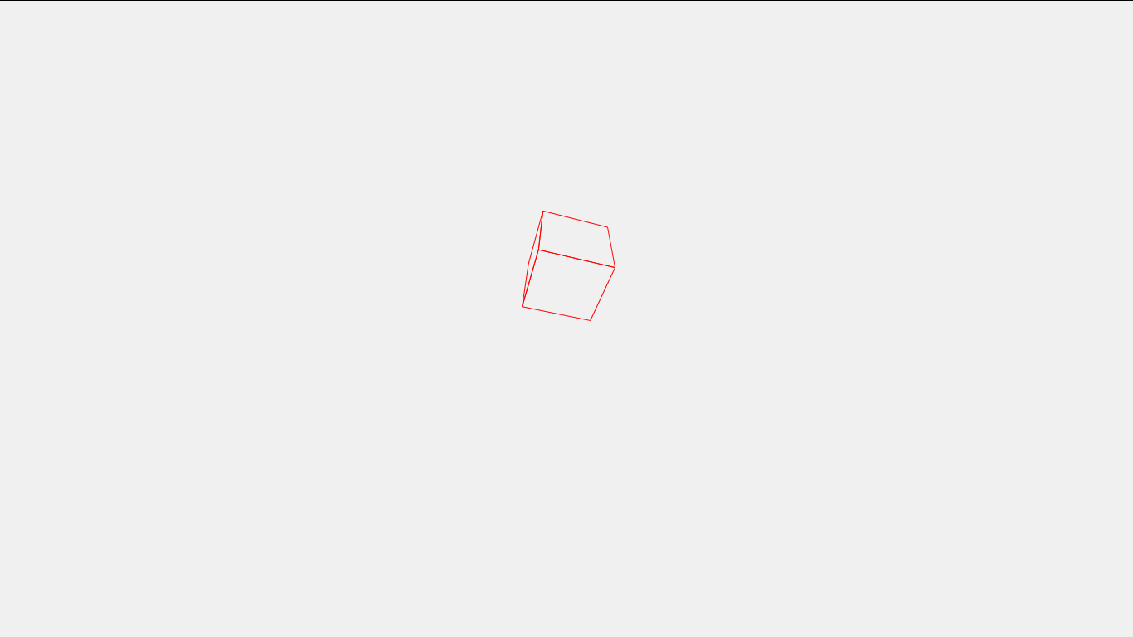

**Figure 1:** This is output of the above code.

If you want a filled box just remove the code **wireframe = true** from the material you will get the box like this

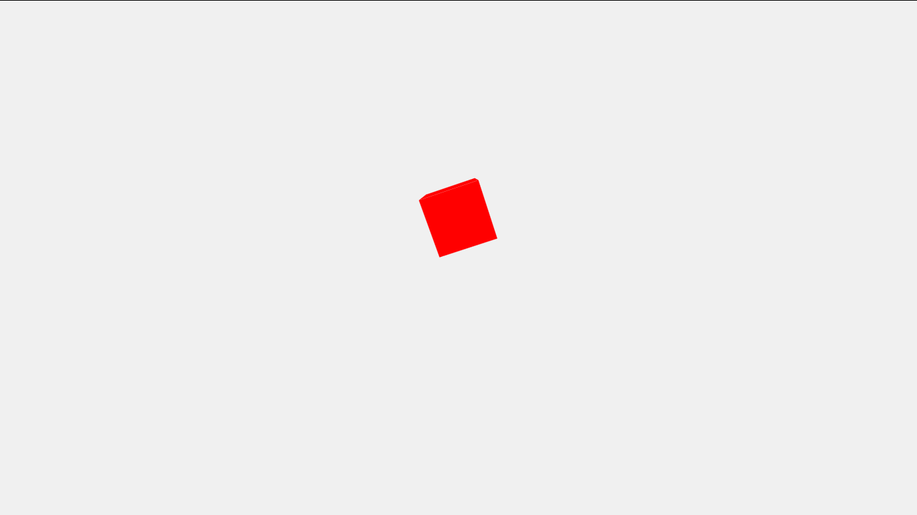

**Figure 2**: Output of wire frame box

From the above we see that there are some basic components that are essential to get started with the THREE.js which are following

* Camera
* Mesh Geometry
* Mesh material
* Light (not in the example)
* Texture(not in the example)

These components were discussed in the literature review in detail.

## Building the Game:

To make the game our first goal is to build a basic structure of the game so that by using that we can easily make our game. This basic structure includes the following components.

* A Plane with road texture
* A Car (cube structure for the car)
* Car Movement (Movement of the cube from the keyboard)

### Plane making:

As car needs a road to run so first we make a plane and add to the scene so that we can put the road texture on it so that it looks like the road. To make the plane set the geometry to the Plane Geometry and set material too, in material we will give the texture of the road to plane so that it feels like road, for giving texture we will need the following code

***var*** texture **=** THREE**.**ImageUtils**.**loadTexture**(**"images/road.jpg"**);**

texture**.**wrapS **=** texture**.**wrapT **=** THREE**.**RepeatWrapping**;**

texture**.**repeat**.**set**(**1**,** 1**);**

Now set the material and the geometry of the plane and give texture to the plane.

groundBasic **=** ***new*** THREE**.**MeshLambertMaterial**({**

color **:** 0x473e34**,**

map **:** texture

**});**

//groundBasic.color.setHSV( 0.1, 0.45, 0.995 );

ground **=** ***new*** THREE**.**Mesh**(*new*** THREE**.**PlaneGeometry**(**10000**,** 10000**,** 80**,** 80**),** groundBasic**);**

ground**.**position**.**y **=** 0**;**

ground**.**rotation**.**x **=** **(-**Math**.**PI **/** 2**);**

ground**.**rotation**.**z **=** Math**.**PI **/** 2**;**

//ground.rotation.y = -Math.PI / 2;

ground**.**receiveShadow **=** ***true*;**

scene**.**add**(**ground**);**

in this code we made a plane consists of the Mesh Lambert Material and give it the texture of road to it so that it looks like the road and then we sets its position and rotation of x, y and z-axis. Here one thing is to note that in THREE.js **z-axis** is **horizontal** and **x-axis** is **vertical** and **y-axis** is the third dimension that is perpendicular to both of the axis in the upward direction. So we need to rotate the x-axis and z-axis of the texture so that it can fit in the scene and seems like a road structure.

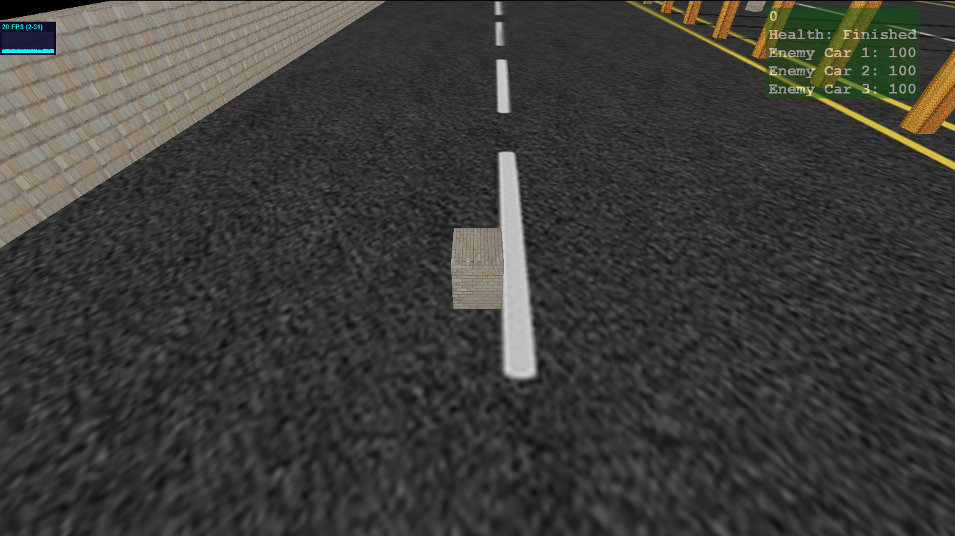

**Figure 3:** Output of the above code

### Car making:

for making the car for this moment we need a cube geometry, but note that we can also import the 3D models of the cars and play we them but right now we will use the cube structure for the car and will play with that structure.

For this we first set the geometry to the Cube Geometry and the material to the mesh Lambert material so that it can have effect to the lights too. Than we add the car in to the scene.

***var*** carGeometry **=** ***new*** THREE**.**CubeGeometry**(**100**,** 100**,** 100**);**

***var*** carMaterial **=** ***new*** THREE**.**MeshLambertMaterial**({**

color **:** 0x000000**,**

//shading : THREE.FlatShading,

overdraw **:** ***true*,**

map **:** texture

**});**

car **=** ***new*** THREE**.**Mesh**(**carGeometry**,** carMaterial**);**

myWorld**.**setWorldCar**();**

car**.**position**.**x **=** myWorld**.**myCar**.**position**.**x**;**

car**.**position**.**y **=** myWorld**.**myCar**.**position**.**y**;**

car**.**position**.**z **=** myWorld**.**myCar**.**position**.**z**;**

car**.**castShoadow **=** ***true*;**

car**.**receiveShadow **=** ***true*;**

collidableMesh**.**push**(**car**);**

scene**.**add**(**car**);**

In this code we are making the car structure that is just the cube and set the position of car in the scene and set the shadow property of the car to true so that it can make shadow and can receive the shadow cast from the other Meshes of the scene. In the last line we are just adding the car cube in to the scene.

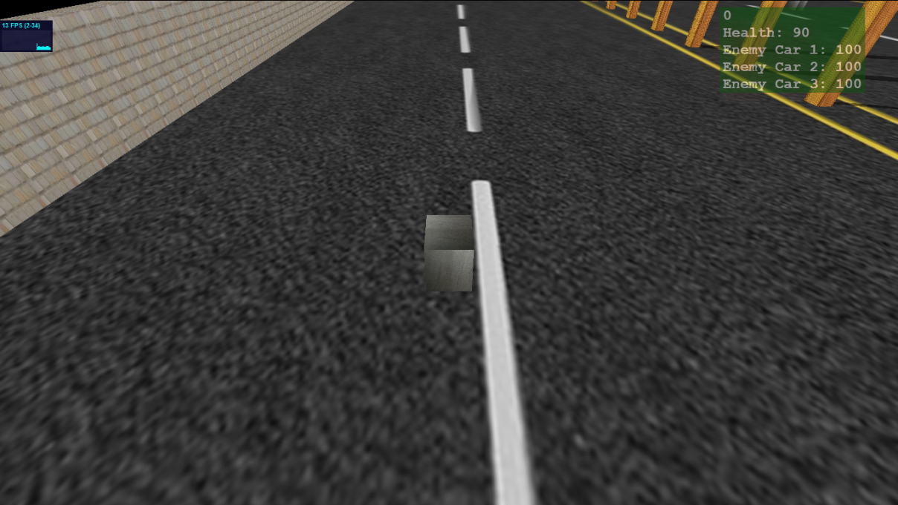

**Figure 4:** Output of the above code

### Car Movement Controls:

As we have now build the car structure and road structure now we need to move the car the from the Keyboard input for this we will need another JavaScript API that communicates with the keyboard input and the API is **THREEx.KeyboardState.js.**

***if*** **(**keyboard**.**pressed**(**"A"**))** **{**

…..

**}**

***if*** **(**keyboard**.**pressed**(**"D"**))** **{**

…..

**}**

***if*** **(**keyboard**.**pressed**(**"W"**))** **{**

**…..**

**}**

***if*** **(**keyboard**.**pressed**(**"S"**))** **{**

**…..**

**}**

If **“A”** key pressed car will turn to left and if **“W”** key is pressed car will move forward and so on. Here we put our logic to control the car.

### Walls and Trees making:

As now we have built the basic structure of our game in which we have a road and a car with its control. Now we will build the walls and trees following the same fashion as we did in making the car. We need boundary walls so that car cannot move from it and need some trees in the scene so that it gives a natural look to our game.

We made the walls and trees using the Cube Geometry, sets its height, width and length according to the need or requirements, and give material and texture to the meshes so that it feels like a tree or walls and gave them the position in the scene below is view of the front wall and there are some trees at the side.

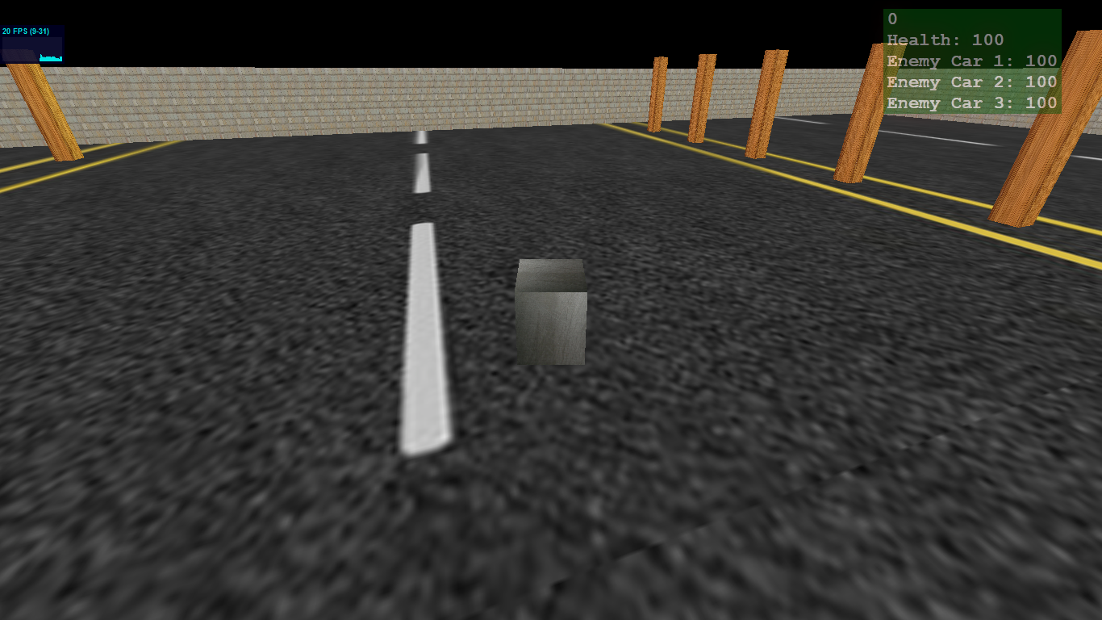

**Figure 5:** Wall and trees

### Setting up the Lights:

Here we explain how to introduce the lights in the scene, we can use multiple types of lights at a time, and here we used only two types of the lights Ambient and Directional light.

***var*** ambientLight **=** ***new*** THREE**.**AmbientLight**(**0xffffff**);**

scene**.**add**(**ambientLight**);**

Above is the code to initialize the ambient light and to add in the scene. In the parameter of the function we pass the color of the light that we want, here we used the white light.



**Figure 6**: Output with white light

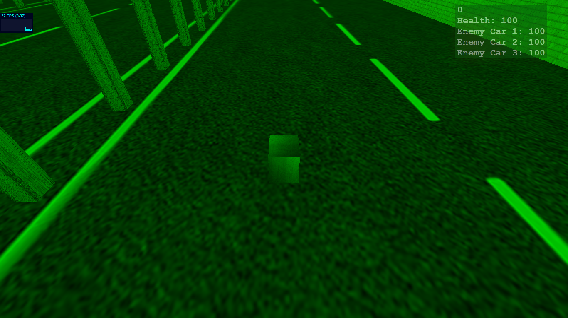

**Figure 7:** Output with **GREEN** light

Second light that we used with the ambient light is directional and the purpose of using the directional light is to cast shadow of the meshes that are in the scene as ambient light is not capable of producing the shadows.

***var*** directionalLight **=** ***new*** THREE**.**DirectionalLight(0x1a4d06**);**

directionalLight**.**position**.**x **=** **-**1000**;**

directionalLight**.**position**.**y **=** 100**;**

directionalLight**.**position**.**z **=** 4000**;**

directionalLight**.**castShadow **=** ***true*;**

scene**.**add**(**directionalLight**);**

Above is code of the directional light as it comes from a specific direction unlike the ambient light so this light needs to set its position that’s why we had sated the x, y and z position.

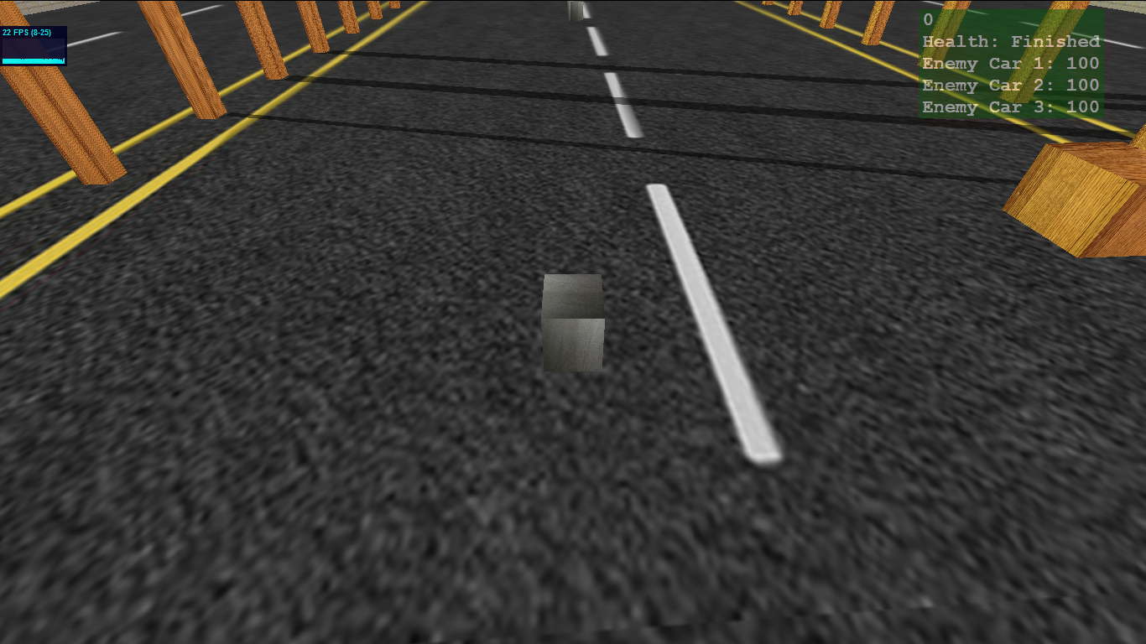

**Figure 8:** Output with the **Directional** Light

In function parameter we send the color of the light that we want from the directional light just like the ambient light. In above Figure we can see the shadows of the trees, that is the purpose to use the directional light in the scene. It good to know that spot light is also used for casting shadows of the object another thing to note that if want a mesh to cast the shadow we have to enable its shadow property. Syntax to enable shadow property is given below

MeshName.castShadow = *true*;

If we want the mesh to receive the shadow too than use this command

MeshName.receiveShadow = *true*;

In the above picture we can see that trees are casting the shadows so their *shadowCasting* property is enable and road is receiving the shadow so its *shadowReceiving* property is true.

## Collision Detection:

As we have built almost all the basic component of the walls, trees, roads and car. Now we have to set the collision between the different components of the scene as collision between the car and the walls and trees. There are basically two types of the collision which are following.

* Discrete Collision
* Continues Collision

### Discrete Collision:

In discrete collision things collide with each other and then we came to know that they are colliding with each other.

### Continues Collision:

In this collision we can calculate when things will collide with each other and we can avoid the collision, and in the most of the games used this technique to calculate the collision so that they can help the player regarding the collision.

## Ways to detect the collision:

As we have seen that there are basically two ways to calculate the collision and there are basically two ways to detect the collision. Two ways are following

* Bounding Box
* Ray Casting

### Bounding Box:

Although this is an old technique but somehow use in some of the games. In this technique we enclose the objects of games in a transparent box and set the collision on that box. In this technique collision is very simple but there is drawback of this technique that it could set the perfect collision on an irregular shape object. As shown in the figure below

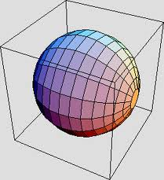

**Figure 9:** Bounding Box

In this picture we have sphere enclose in a box and it is clearly seen that box shape is not fit for the sphere and hence perfect collision will not be achieved in this case.

### Ray Casting:

This is most popular technique now-a-days in the game development. In this technique rays are emitted from the objects and it to other objects in the scene and when the length of the ray become zero or in other words if the distance between the objects in the scene became zero its means that the collision occur. In this technique we can achieve the perfect collision in terms of the shapes, whatever the shapes are it does not matter, collision only occur when rays hit any object.

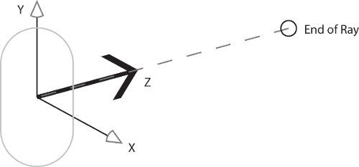

**Figure 10**: Ray Example

In our game we also focused on the second technique to do collision. We used the ray casting to achieve the collision, basic logic to use this technique is that put all of the object that can collide with the Player car in an array, like the walls and trees, than we emit rays from the player car in the direction of the objects that can be collide with player’s car, if any collision occur the car stops at the moment. Fortunately there is way for ray casting in THREE.js API built-in for the ray casting so we just give objects to that function after some calculations and it gives us the result, below is the overview of the code.

***var*** originPoint **=** **PLAYER.**position**.**clone**();**

***for*** **(*var*** vertexIndex **=** 0**;** vertexIndex **<** **PLAYER.**geometry**.**vertices**.**length**;** vertexIndex**++)** **{**

***var*** localVertex **=** **PLAYER.**geometry**.**vertices**[**vertexIndex**].**clone**();**

***var*** globalVertex **=** **PLAYER.**matrix**.**multiplyVector3**(**localVertex**);**

***var*** directionVector **=** globalVertex**.**subSelf**(PLAYER.**position**);**

**// RAY Casting Function**

***var*** ray **=** ***new*** THREE**.**Ray**(PLAYER.position,** directionVector**.**clone**().**normalize**());**

***var*** collisionResults **=** ray**.**intersectObjects**(ArrayOfCollideableObjects);**

***if*** **(**collisionResults**.**length **>** 0 **&&** collisionResults**[**0**].**distance **<** directionVector**.**length**())** **{**

**…..**

**}**

In above code we have ray casting function that is built-in the THREE.js API. It takes four parameters

* Origin of the ray
* Direction Of the ray
* Near
* Far

But there are two parameters that are used mainly and need to be focused

**Origin of the Ray:**

In this parameter we send the position of that object that we want to emit the rays. In our case it is the position of the Player, so we send the player Position.

**Direction of the Ray:**

second parameter is the direction, in which direction we want to emit the rays, so we calculate the direction of the rays through the direction vector and give the direction of the function and then we save the result in an variable that comes from the

ray**.**intersectObjects**(ArrayOfCollideableObjects);**

It gives the objects through which the rays collide. Secondly if we want to set the collision only on one object then we will use this

ray**.**intersectObject**(CollideableObject);**

remember the difference between the function name that changes from *intersectObjects* to *intersectObject* only and note the parameter also it takes only one object not whole of the array of collide able objects.

## Calculate the distance:

There is another way that we used in our game is to manually calculate the positions, vertices and geometry of the objects and check for the collision. If the distance between them is less some specific value its mean that there is collision occur between them but this technique is not good one but we use this technique in bucket collision and will explain why we use this instead of the ray casting.

## Bullet Creation:

As we have build most of the basic components of our game, now we are going to built the bullet firing logic. There are two basic questions while creating the bullet logic, that is

* When a player fires a bullet from his gun, does the bullet really travel from his gun to the given target or do they completely ignore this part and just put a bullet hole on the target?
* If the bullet is really travelling from the gun to the target, at what speed is it actually travelling?

Answer to these questions is that,

* Most of the games don’t simulate the bullet in the game rather they just put the bullet spot on the target. If the distance is short then they simulate the bullet but this is not compulsory or necessary as it is totally depend on the need of the game. Second thing is that if there are low speed objects like missiles, rockets than they simulate these types of objects and these things can be seen in the screen while travelling.

Now the question arises how to fire the bullet. There are two techniques in this regard.

* Fake tracer
* Ray casting

### Fake tracer:

In this technique a fake tracer is fired after every fixed interval that locate the position of the bullet, interval can be the number of the bullets fired like when number of the bullet firing count is multiple of the three then a tracer will be fired and the speed of the tracer is very fast but it is rather it is better to say that it is spontaneous.

### Ray casting:

This technique is same as we discussed in the collision part. Now-a-days most first person shooter (FPS) games used this technique. In this a ray is cast in the direction of the target and the bullet travel along the ray.

We also used this way bullet firing and cast the ray from the player to fire the bullet. As we discussed early that for casting the ray we need to calculate the origin point and the direction. So we have the origin point is player position in the case when player is firing the bullet and in case of the enemy it’s the enemy position. For the direction of the ray we take camera as the reference point if the player fires the bullet and when the enemy fires the bullet player position is the reference point for the enemy to cast the ray. Here is code for bullet creation.

***var*** bullet **=** ***new*** THREE**.**Mesh**(**bulletGeo**,** bulletMaterial**);**

bullet**.**position**.**set**(**obj**.**position**.**x**,** **(**obj**.**position**.**y **+** 15**)** **\*** 0.8**,** obj**.**position**.**z**);**

// var originPoint = bullet.position.clone();

***if*** **(**obj **===** localObject**)** **{**

***var*** vector **=** camera**.**position**.**clone**();**

bullet**.**ray **=** ***new*** THREE**.**Ray**(**obj**.**position**,** vector**.**subSelf**(**obj**.**position**).**normalize**());**

**}**

***else*** **{**

***var*** vector **=** obj2**.**position**.**clone**();**

bullet**.**ray **=** ***new*** THREE**.**Ray**(**obj**.**position**,**vector**.**subSelf**(**obj**.**position**).**normalize**());**

**}**

bullet**.**owner **=** obj**;**

bullets**.**push**(**bullet**);**

scene**.**add**(**bullet**);**

For the shape of the bullet we make a sphere. Here in the code we have a bullet.owner function. We are just telling by this function who is the owner of the bullet mean who fires the bullet whether it is the player car or the enemy’s car. Here is the important thing to note that we pushed the bullets in the array of bullets so that we can render the bullets in the rendering part by taking them from the array. Here is code for rendering the bullet.

***for*** **(*var*** i **=** bullets**.**length **-** 1**;** i **>=** 0**;** i**--)** **{**

***var*** b **=** bullets**[**i**];**

d **=** b**.**ray**.**direction**;**

***if*** **(!**hit**)** **{**

//b.rotation.x = Math.PI / 2;

b**.**translateX**(**bspeed **\*** **(**d**.**x**));**

b**.**translateZ**(**bspeed **\*** **(**d**.**z**));**

**}**

Here we are calculating the ray direction of the bullet and make the bullet travel along the X-axis and Z-axis. **translateX** and **translateZ** are the functions to move the bullet in the scene with some speed if the bullet does not hit any object and if hits any object in the scene it should disappear from the scene and we used this function to make the bullet vanish after hitting the object

scene.remove(objectName).

Object can be any object. It can be bullet, a wall or tree. By calling this function it will the object will goes off from the screen.

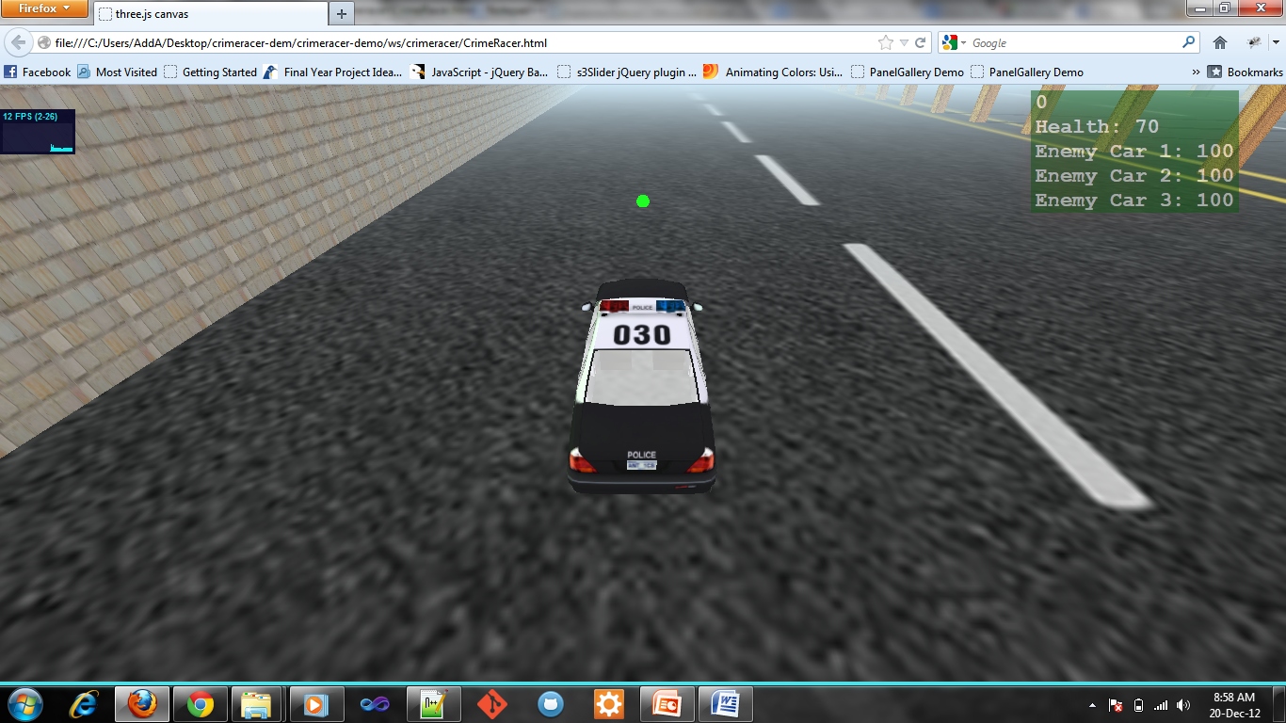

**Figure 11:** Output of bullet Creation

In the figure the green sphere is bullet which is fired by the player.

## Enemies Creation:

Now we are going to add some enemies in the game so that player can fight with some of the enemies and fire bullets on the enemies and enemies also firing on the player. For enemies car we used the same logic and same pattern as we used in the player’s car creation. Player’s car movement is controlled by the keyboard but enemies’ car movement is control by the computer itself but there is no artificial intelligence still in the movement of the enemies’ car but we will put the movement AI in the enemies’ car later on. Here our basic aim is to add some dummy enemies that are firing on the player car and the player’s car also fire bullets on the enemies’ car. Rest of logic for firing the bullet by the enemy’s car is totally same as the player’s car logic. We also explained the bullet firing code above.

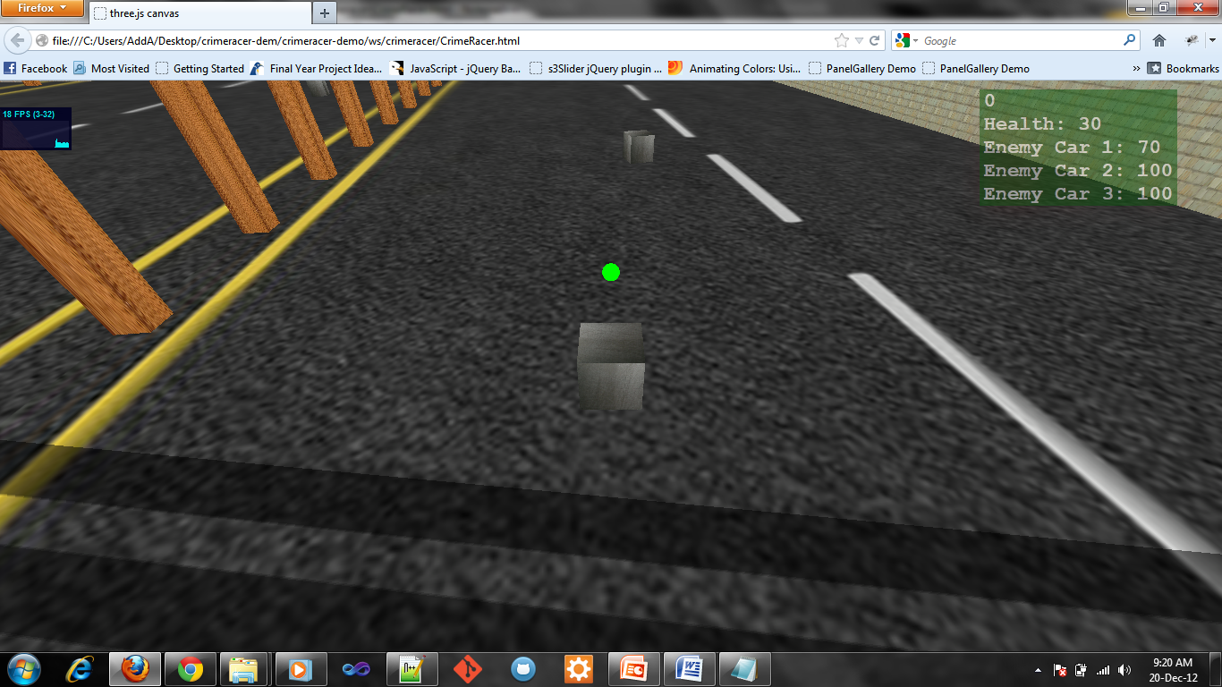

**Figure 12:** Player car fire bullet on enemy’s car

Enemies car movement is depend upon the time interval till now, mean for the fixed time interval it will move forward and right for next it will move left or for the next interval it will move backward, but we will put AI in the movement of the cars in the next part of the project.